**Current Software Architecture**

Software architecture refers to the high level structures of a [software system](https://en.wikipedia.org/wiki/Software_system) and the discipline of creating such structures and systems. Each structure comprises software elements, relations among them, and properties of both elements and relations. The architecture of a software system is a metaphor, analogous to the [architecture](https://en.wikipedia.org/wiki/Architecture) of a building. It functions as a blueprint for the system and the developing project, laying out the tasks necessary to be executed by the design teams.

This CSE Department Academic Resource Management System is accessed by the users through web browsers connected to the internet and the website provide all the necessary menus, navigations and materials from the webserver as well as the cloud storage provider (CSP).The system’s architecture could be explained as follows:

* The website would provide a user interface or web page for ordinary users, instructors and administrators. This front end web system provides information and services to the users as well as a content management system for instructors and administrators.
* The webserver would contain the web site data, domain, subdomains, configurations, a storage space as well as a database that hold the information of all activities and services.
* 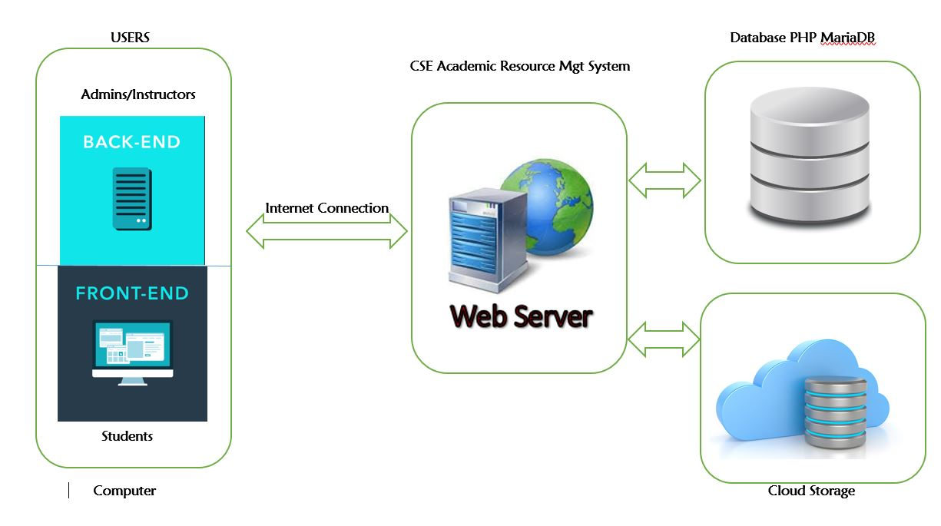The cloud storage would provide a storage space for the resources that are managed and organized by the system (CRMS) with capability to generate links to acquire the resources from the website.

**4.3. Proposed Software Architecture**

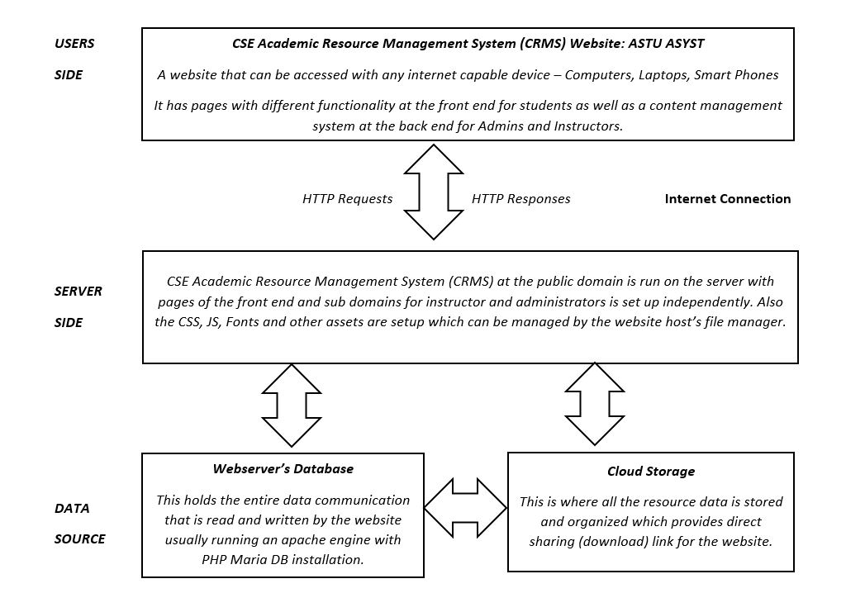**4.3.1 Overview**

The system architecture can further more be represented by the following diagrams. It shows the entire interaction among the users (Students, Instructors, and Administrators) and the web system and also between the cloud storage and databases.

**Client Server Communication**

The client while trying to get the services of the system sends http requests to the website server which is analyzed through a parse PHP decoder. It also uses a composer JSON object to perform operations at the backend resulting changes at the database smoothly provided by the ASF with

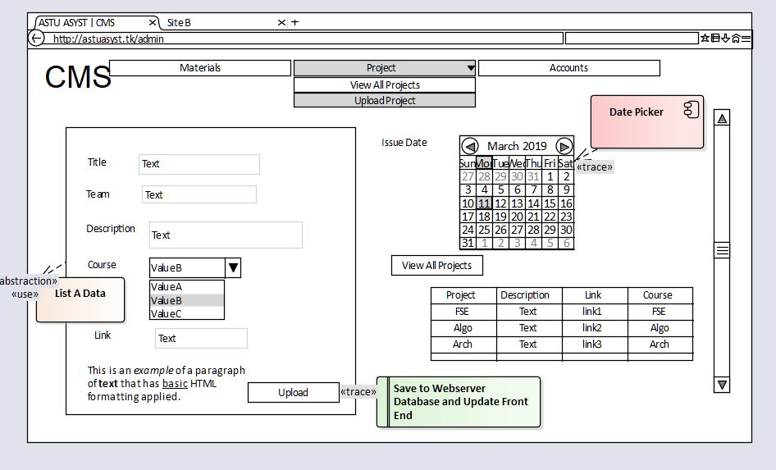

Auto Configuration Server (ACS).

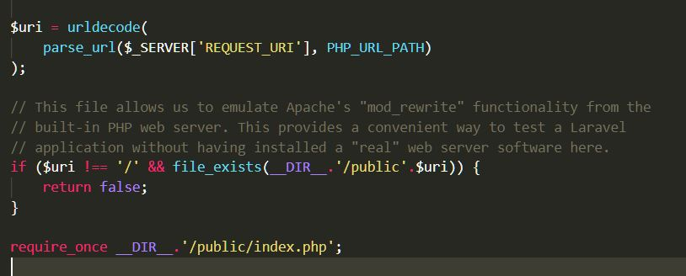

Then that request is processed through a pre-configured environmnet protocol, verified and suddent executed accordingly.

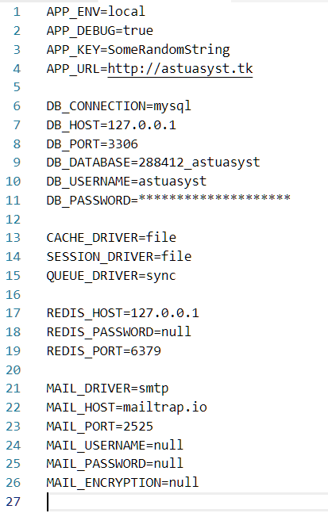

**System Process**

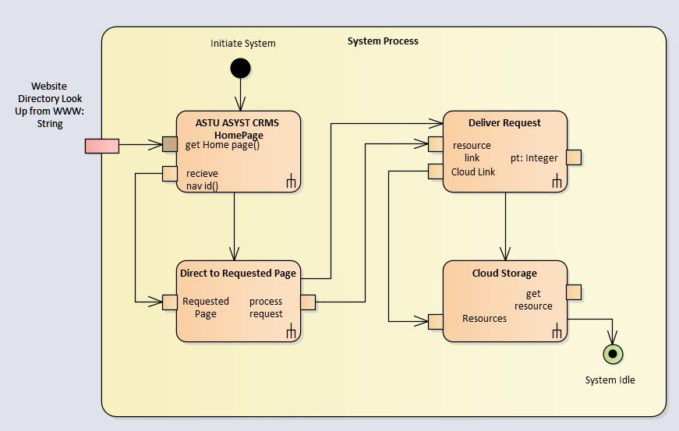The following diagram represents of a system process of how a front end user; Student can access the system and get services.

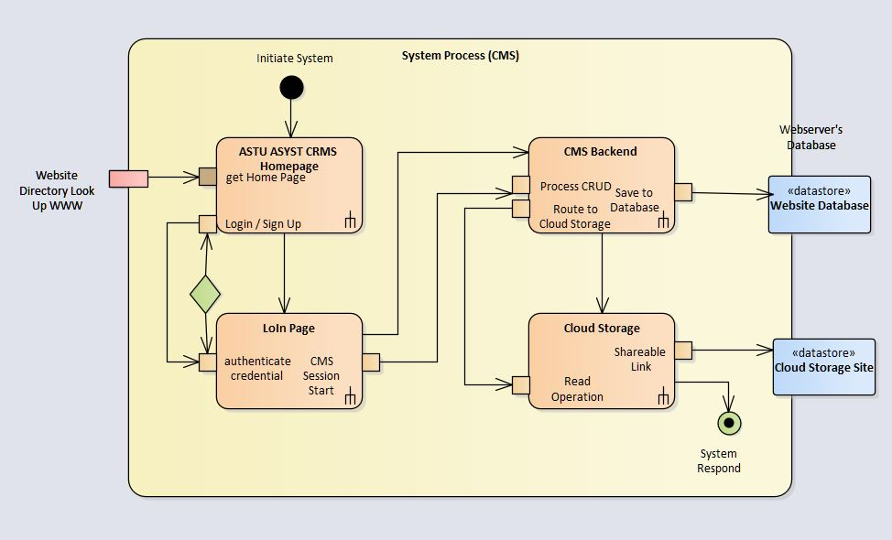The following diagram represents of a system process of how a back end / content management system user; Admins or Instructors operate and make changes to the system.

